SuperCharge
Your Social Life
Meet People, Make Friends, Have Fun
meals walks pubs cinema parties theatre and more
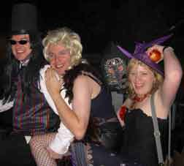 | 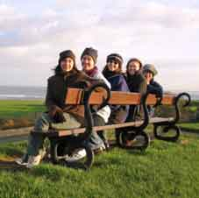

- We are an informal club offering social, cultural and sporting activities
- We meet every Wednesday in town to welcome new members, arrange events and to socialise
- First Wednesday of every Month is our special New Members night at the Garden House on the Hagley Rd from 8:30pm.
- Come along on a Wednesday to join or to find out more
- Non-commercial, not for profit

What our members say…

- I wish I had found this club years ago
- So many events, so much fun
- A really friendly welcoming bunch of people

www.BirminghamIVC.org

Ph/Txt: 07552 806 112

